Source Code Of Deploying ELK Stack On Docker Container

1.Create Controller

package com.example;

import org.springframework.web.bind.annotation.GetMapping;

import org.springframework.web.bind.annotation.RestController;

@RestController

public class HelloController {

@GetMapping("/")

public String hello() {

return "hi learners welcome to Docker!";

}

}

2.pom.xml

<project xmlns="http://maven.apache.org/POM/4.0.0"

xmlns:xsi="http://www.w3.org/2001/XMLSchema-instance"

xsi:schemaLocation="http://maven.apache.org/POM/4.0.0 http://maven.apache.org/xsd/maven-4.0.0.xsd">

<modelVersion>4.0.0</modelVersion>

<groupId>com.example</groupId>

<artifactId>docker-demo</artifactId>

<version>1.0-SNAPSHOT</version>

<packaging>war</packaging>

<properties>

<java.version>11</java.version>

</properties>

<dependencies>

<dependency>

<groupId>org.springframework.boot</groupId>

<artifactId>spring-boot-starter-web</artifactId>

</dependency>

</dependencies>

<build>

<plugins>

<plugin>

<groupId>org.springframework.boot</groupId>

<artifactId>spring-boot-maven-plugin</artifactId>

</plugin>

</plugins>

</build>

</project>

3.After creating maven then we have create docker images and push the image in docker hub

FROM openjdk:11-jre-slim

COPY target/docker-demo-1.0-SNAPSHOT.war /app.war

EXPOSE 8080

CMD ["java", "-jar", "/app.war"]

Build docker image

docker build -t docker-demo .

**Push the Docker Image to Docker Hub**

docker login

docker tag docker-demo <your-docker-hub-username>/<repository-name>:latest

docker push <your-docker-hub-username>/<repository-name>:latest

**Generate Output**

docker run -p 8080:8080 -d <your-docker-hub-username>/<repository-name>:latest

5.Then after creating docker image then we have to use kubernate

i.create a pod



ii.list of pods

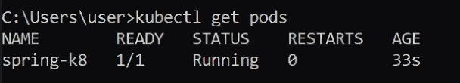

iii.create deployment



iv.list of deployment

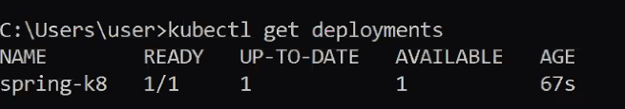

v.Default replica of the pod

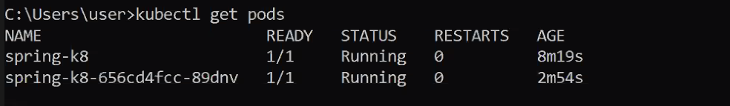

vi.create service



vii.check the services are up

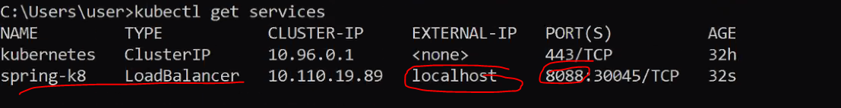

ix.check the logs are validate or not

